如何从零绘制k线图 -- 原生js canvas图表绘制
样式如下图
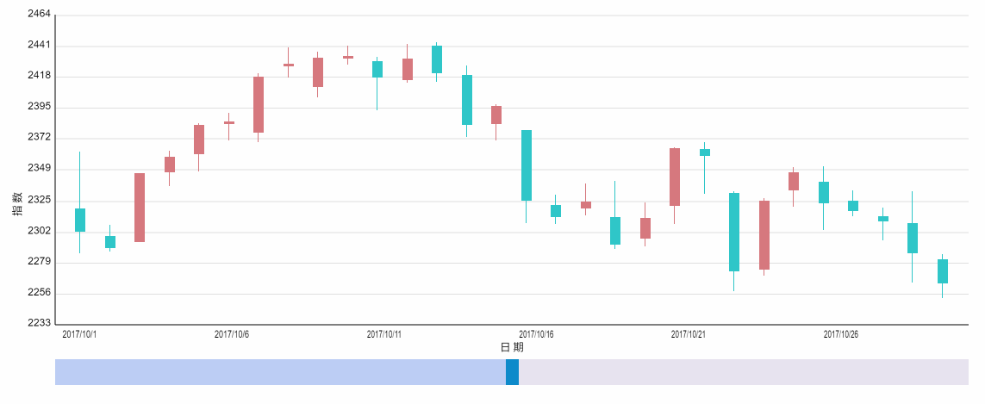

源码地址： https://github.com/sutianbinde/charts
演示地址：kchart.html
编写这个需要具备canvas基础，如果没有canvas基础可以学习我前面的cnavas基础博客。

具体步骤

创建html文件，然后我们在页面中写一个用于放图表的 div
然后在js中写入数据，和 绘制图表的方法 （数据是一个三维数组，每一个k点值中包含了日期 还包含了一个 表示 开盘/收盘/最低/最高 值的数组）
<!DOCTYPE html><html><head lang="en">
<meta charset="UTF-8">
<title></title></head><body>

<div id="chart" height="500" width="1200" style="margin:30px;"></div>

<script type="text/javascript">
function goChart(cBox, dataArr){

}

// 时间 开盘 收盘 最低 最高
var dataArr = [
["2017/10/1", [2320.26,2302.6,2287.3,2362.94]],
["2017/10/2", [2300,2291.3,2288.26,2308.38]],
["2017/10/3", [2295.35,2346.5,2295.35,2346.92]],
["2017/10/4", [2347.22,2358.98,2337.35,2363.8]],
["2017/10/5", [2360.75,2382.48,2347.89,2383.76]],
["2017/10/6", [2383.43,2385.42,2371.23,2391.82]],
["2017/10/7", [2377.41,2419.02,2369.57,2421.15]],
["2017/10/8", [2425.92,2428.15,2417.58,2440.38]],
["2017/10/9", [2411,2433.13,2403.3,2437.42]],
["2017/10/10", [2432.68,2434.48,2427.7,2441.73]],
["2017/10/11", [2430.69,2418.53,2394.22,2433.89]],
["2017/10/12", [2416.62,2432.4,2414.4,2443.03]],
["2017/10/13", [2441.91,2421.56,2415.43,2444.8]],
["2017/10/14", [2420.26,2382.91,2373.53,2427.07]],
["2017/10/15", [2383.49,2397.18,2370.61,2397.94]],
["2017/10/16", [2378.82,2325.95,2309.17,2378.82]],
["2017/10/17", [2322.94,2314.16,2308.76,2330.88]],
["2017/10/18", [2320.62,2325.82,2315.01,2338.78]],
["2017/10/19", [2313.74,2293.34,2289.89,2340.71]],
["2017/10/20", [2297.77,2313.22,2292.03,2324.63]],
["2017/10/21", [2322.32,2365.59,2308.92,2366.16]],
["2017/10/22", [2364.54,2359.51,2330.86,2369.65]],
["2017/10/23", [2332.08,2273.4,2259.25,2333.54]],
["2017/10/24", [2274.81,2326.31,2270.1,2328.14]],
["2017/10/25", [2333.61,2347.18,2321.6,2351.44]],
["2017/10/26", [2340.44,2324.29,2304.27,2352.02]],
["2017/10/27", [2326.42,2318.61,2314.59,2333.67]],
["2017/10/28", [2314.68,2310.59,2296.58,2320.96]],
["2017/10/29", [2309.16,2286.6,2264.83,2333.29]],
["2017/10/30", [2282.17,2263.97,2253.25,2286.33]],
["2017/11/1", [2320.26,2302.6,2287.3,2362.94]],
["2017/11/2", [2300,2291.3,2288.26,2308.38]],
["2017/11/3", [2295.35,2346.5,2295.35,2346.92]],
["2017/11/4", [2347.22,2358.98,2337.35,2363.8]],
["2017/11/5", [2360.75,2382.48,2347.89,2383.76]],
["2017/11/6", [2383.43,2385.42,2371.23,2391.82]],
["2017/11/7", [2377.41,2419.02,2369.57,2421.15]],
["2017/11/8", [2425.92,2428.15,2417.58,2440.38]],
["2017/11/9", [2411,2433.13,2403.3,2437.42]],
["2017/11/10", [2432.68,2434.48,2427.7,2441.73]],
["2017/11/11", [2430.69,2418.53,2394.22,2433.89]],
["2017/11/12", [2416.62,2432.4,2414.4,2443.03]],
["2017/11/13", [2441.91,2421.56,2415.43,2444.8]],
["2017/11/14", [2420.26,2382.91,2373.53,2427.07]],
["2017/11/15", [2383.49,2397.18,2370.61,2397.94]],
["2017/11/16", [2378.82,2325.95,2309.17,2378.82]],
["2017/11/17", [2322.94,2314.16,2308.76,2330.88]],
["2017/11/18", [2320.62,2325.82,2315.01,2338.78]],
["2017/11/19", [2313.74,2293.34,2289.89,2340.71]],
["2017/11/20", [2297.77,2313.22,2292.03,2324.63]],
["2017/11/21", [2322.32,2365.59,2308.92,2366.16]],
["2017/11/22", [2364.54,2359.51,2330.86,2369.65]],
["2017/11/23", [2332.08,2273.4,2259.25,2333.54]],
["2017/11/24", [2274.81,2326.31,2270.1,2328.14]],
["2017/11/25", [2333.61,2347.18,2321.6,2351.44]],
["2017/11/26", [2340.44,2324.29,2304.27,2352.02]],
["2017/11/27", [2326.42,2318.61,2314.59,2333.67]],
["2017/11/28", [2314.68,2310.59,2296.58,2320.96]],
["2017/11/29", [2309.16,2286.6,2264.83,2333.29]],
["2017/11/30", [2282.17,2263.97,2253.25,2286.33]]
];

goChart(document.getElementById("chart"),dataArr);

</script></body></html>

申明需要的变量，并且初始化图表（js写在 goChart方法中）
所有变量的一样我已经在注释中注明，大家先不用特别理解，到后面用到的时候就知道了
// 声明所需变量
var canvas,ctx; //canvas DOM canvas上下文
// 图表属性
var cWidth, cHeight, cMargin, cSpace; //canvas中部的宽/高 canvas内边距/文字边距
var originX, originY; //坐标轴原点
// 图属性
var bMargin, tobalBars, bWidth, maxValue, minValue; //每个k线图间间距 数量 宽度 所有k线图的最大值/最小值
var totalYNomber; //y轴上的标识数量
var showArr; //显示出来的数据部分（因为可以选择范围，所以需要这个数据）

//范围选择属性
var dragBarX,dragBarWidth; //范围选择条中的调节按钮的位置，宽度

// 运动相关变量
var ctr, numctr, speed; //运动的起步，共有多少步，运动速度（timer的时间）
//鼠标移动
var mousePosition = {}; //用户存放鼠标位置

// 创建canvas并获得canvas上下文
canvas = document.createElement("canvas");
if(canvas && canvas.getContext){
ctx = canvas.getContext("2d");
}

canvas.innerHTML = "你的浏览器不支持HTML5 canvas";
cBox.appendChild(canvas);

initChart(); // 图表初始化

// 图表初始化
function initChart(){
// 图表信息
cMargin = 60;
cSpace = 80;
//将canvas扩大2倍，然后缩小，以适应高清屏幕
canvas.width = cBox.getAttribute("width")* 2 ;
canvas.height = cBox.getAttribute("height")* 2;
canvas.style.height = canvas.height/2 + "px";
canvas.style.width = canvas.width/2 + "px";
cHeight = canvas.height - cMargin*2-cSpace*2;
cWidth = canvas.width - cMargin*2-cSpace*2;
originX = cMargin + cSpace;
originY = cMargin + cHeight;

showArr = dataArr.slice( 0,parseInt(dataArr.length/2) );

// 柱状图信息
tobalBars = showArr.length;
bWidth = parseInt( cWidth/tobalBars/3);
bMargin = parseInt( (cWidth-bWidth*tobalBars)/(tobalBars+1) );
//算最大值，最小值
maxValue = 0;
minValue = 9999999;
for(var i=0; i<dataArr.length; i++){
var barVal = dataArr[i][1][3] ;
if( barVal > maxValue ){
maxValue = barVal;
}
var barVal2 = dataArr[i][1][2] ;
if( barVal2 < minValue ){
minValue = barVal2;
}

}
maxValue += 20; //上面预留20的空间
minValue -= 20; //下面预留20的空间
totalYNomber = 10;
// 运动相关
ctr = 1;
numctr = 50;
speed = 2;

dragBarWidth = 30;
dragBarX = cWidth/2+cSpace+cMargin-dragBarWidth/2;

}

接着上一步的代码 绘制坐标轴和标记
drawLineLabelMarkers(); // 绘制图表轴、标签和标记
// 绘制图表轴、标签和标记
function drawLineLabelMarkers(){
ctx.font = "24px Arial";
ctx.lineWidth = 2;
ctx.fillStyle = "#000";
ctx.strokeStyle = "#000";
// y轴 drawLine(originX, originY, originX, cMargin);
// x轴
drawLine(originX, originY, originX+cWidth, originY);

// 绘制标记 drawMarkers();
}

// 画线的方法
function drawLine(x, y, X, Y){
ctx.beginPath();
ctx.moveTo(x, y);
ctx.lineTo(X, Y);
ctx.stroke();
ctx.closePath();
}

// 绘制标记
function drawMarkers(){
ctx.strokeStyle = "#E0E0E0";
// 绘制 y
var oneVal = (maxValue-minValue)/totalYNomber;
ctx.textAlign = "right";
for(var i=0; i<=totalYNomber; i++){
var markerVal = parseInt(i*oneVal+minValue);;
var xMarker = originX-10;
var yMarker = parseInt( originY-cHeight*(markerVal-minValue)/(maxValue-minValue) );
ctx.fillText(markerVal, xMarker, yMarker+3, cSpace); // 文字
if(i>0){
drawLine(originX+2, yMarker, originX+cWidth, yMarker);
}
}

// 绘制 x
var textNb = 6;
ctx.textAlign = "center";
for(var i=0; i<tobalBars; i++){
if(tobalBars>textNb && i%parseInt(tobalBars/6) != 0 ){
continue;
}
var markerVal = dataArr[i][0];
var xMarker = parseInt( originX+cWidth*(i/tobalBars)+bMargin+bWidth/2 );
var yMarker = originY+30;
ctx.fillText(markerVal, xMarker, yMarker, cSpace); // 文字 }
// 绘制标题 y ctx.save();
ctx.rotate(-Math.PI/2);
ctx.fillText("指 数", -canvas.height/2, cSpace-20); ctx.restore();
// 绘制标题 x
ctx.fillText("日 期", originX+cWidth/2, originY+cSpace-20);
};

接着绘制 中间的K图柱子
这里的代码中包含了后面鼠标移动和调节范围的判断代码，现在还看不到其作用
drawBarAnimate(); // 绘制柱状图的动画
//绘制k形图
function drawBarAnimate(mouseMove){
var parsent = ctr/numctr;
for(var i=0; i<tobalBars; i++){
var oneVal = parseInt(maxValue/totalYNomber);
var data = dataArr[i][1];
var color = "#30C7C9";
var barVal = data[0];
var disY = 0;
//开盘0 收盘1 最低2 最高3 跌30C7C9 涨D7797F
if(data[1]>data[0]){ //涨
color = "#D7797F";
barVal = data[1];
disY = data[1]-data[0];
}else{
disY = data[0]-data[1];
}
var showH = disY/(maxValue-minValue)*cHeight*parsent;
showH = showH>2 ? showH : 2 ;

var barH = parseInt( cHeight*(barVal-minValue)/(maxValue-minValue));
var y = originY - barH;
var x = originX + ((bWidth+bMargin)*i + bMargin)*parsent;

drawRect( x, y, bWidth, showH, mouseMove, color,true); //开盘收盘 高度减一避免盖住x轴

//最高最低的线
showH = (data[3]-data[2])/(maxValue-minValue)*cHeight*parsent;
showH = showH>2 ? showH : 2 ;

y = originY - parseInt( cHeight*(data[3]-minValue)/(maxValue-minValue));
drawRect( parseInt(x+bWidth/2-1), y, 2, showH, mouseMove, color); //最高最低 高度减一避免盖住x轴 }
if(ctr<numctr){
ctr++;
setTimeout(function(){
ctx.clearRect(0,0,canvas.width, canvas.height);
drawLineLabelMarkers();
drawBarAnimate();
drawDragBar();
}, speed*=0.03);
}
}

//绘制方块
function drawRect( x, y, X, Y, mouseMove , color, ifBigBar,ifDrag){

ctx.beginPath();

if( parseInt(x)%2 !== 0){ //避免基数像素在普通分辨率屏幕上出现方块模糊的情况
x += 1;
}
if( parseInt(y)%2 !== 0){
y += 1;
}if( parseInt(X)%2 !== 0){
X += 1;
}
if( parseInt(Y)%2 !== 0){
Y += 1;
}
ctx.rect( parseInt(x), parseInt(y), parseInt(X), parseInt(Y) );

if(ifBigBar && mouseMove && ctx.isPointInPath(mousePosition.x*2, mousePosition.y*2)){ //如果是鼠标移动的到柱状图上，重新绘制图表
ctx.strokeStyle = color;
ctx.strokeWidth = 20;
ctx.stroke();
}
//如果移动到拖动选择范围按钮
canvas.style.cursor = "default";
if(ifDrag && ctx.isPointInPath(mousePosition.x*2, mousePosition.y*2)){ //如果是鼠标移动的到调节范围按钮上，改变鼠标样式
//console.log(123);
canvas.style.cursor = "all-scroll";
}
ctx.fillStyle = color;
ctx.fill();
ctx.closePath();

}

接着绘制选择范围的矩形
//绘制拖动轴 drawDragBar();
function drawDragBar(){
drawRect( originX, originY+cSpace, cWidth, cMargin, false, "#E8E4F0");
drawRect( originX, originY+cSpace, dragBarX-originX, cMargin, false, "#BCCEF5");
drawRect( dragBarX, originY+cSpace, dragBarWidth, cMargin, false, "#078ACB",false,true);
}

这样我们的图表基本绘制就完成了
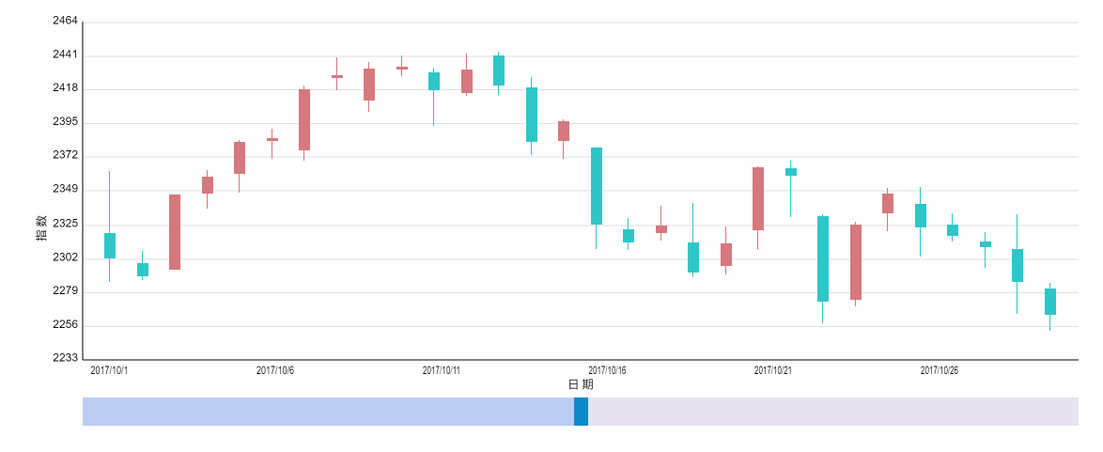

然后监听鼠标移动和拖动选择显示范围
//检测鼠标移动
var mouseTimer = null;
addMouseMove();
function addMouseMove(){
canvas.addEventListener("mousemove",function(e){
e = e || window.event;
if( e.offsetX || e.offsetX==0 ){
mousePosition.x = e.offsetX;
mousePosition.y = e.offsetY;
}else if( e.layerX || e.layerX==0 ){
mousePosition.x = e.layerX;
mousePosition.y = e.layerY;
}

clearTimeout(mouseTimer);
mouseTimer = setTimeout(function(){
ctx.clearRect(0,0,canvas.width, canvas.height);
drawLineLabelMarkers();
drawBarAnimate(true);
drawDragBar();
},10);
});
}
//监听拖拽
canvas.onmousedown = function(e){

if(canvas.style.cursor != "all-scroll"){
return false;
}

document.onmousemove = function(e){
e = e || window.event;
if( e.offsetX || e.offsetX==0 ){
dragBarX = e.offsetX*2-dragBarWidth/2;
}else if( e.layerX || e.layerX==0 ){
dragBarX = e.layerX*2-dragBarWidth/2; }

if(dragBarX<=originX){
dragBarX=originX
}
if(dragBarX>originX+cWidth-dragBarWidth){
dragBarX=originX+cWidth-dragBarWidth
}

var nb = Math.ceil( dataArr.length*( (dragBarX-cMargin-cSpace)/cWidth ) );
showArr = dataArr.slice( 0, nb || 1 );

// 柱状图信息
tobalBars = showArr.length;
bWidth = parseInt( cWidth/tobalBars/3);
bMargin = parseInt( (cWidth-bWidth*tobalBars)/(tobalBars+1) );

}

document.onmouseup = function(){
document.onmousemove = null;
document.onmouseup = null;
}
}

这样整个代码就编写完了 ，感兴趣的同学希望手动实现上面的代码

